Hybrid Power Systems Optimization for Regions of the Far North

V.D. Berdonosov, V.A. Shamak,

A.A. Zivotova, M.V. Zheltov

dept. Information Systems

Komsomolsk-na-Amure State University, KnASU

Komsomolsk-na-Amure, Russia

[berd1946@gmail.com](mailto:berd1946@gmail.com)

*Abstract*— In Russia there are many settlements without connection to the national power grid. Particularly, there are many such of them in the Far North. Power supply of these settlements is seasonal and requires significant costs. On the other side, currently there are many solutions allowing replacing traditional energy resources with renewable ones, such as sun and wind. The article considers comprehensive issues on optimization of hybrid power systems (HPS). There is an optimization algorithm based on energy balance models from daily average to dynamic yearly hourly average. The algorithm is tested on data of one of the Khabarovsk Region settlements. Calculations based on the algorithm and relating to the equipment of mass production shows the possibility of decreasing costs by more than an order.

Keywords—hybrid power systems; Far North regions; optimization algorithm; energy balance; mathematic model; cost criterion

# Introduction

The issues related to the replacement of fossil fuels with renewable energy sources are increasingly being raised and addressed in the world. Power systems using these sources (partially or fully) are hybrid power systems (HPS). Their variety is huge and according to the morphological table (Table 1) can exceed several thousand combinations, even if we stop at only four factors: energy sources, energy accumulators, types (classes) of consumers, HPS structures. Considering the first factor - energy sources, researchers, of course, first of all pay attention to the solar [1, 2, 3, 4, 5, 6, 7, 8, 9, 10, 11] and the wind [2, 3, 4, 5, 6, 7, 9, 10, 11] energy. Much less attention is paid to hydro-power [3, 5, 7, 8, 10] and only a small number of publications address the geothermal [7, 10], hydrogen [1, 4] and bio- [2, 10] energy. The second important factor is the type of energy accumulators. The fact is that renewable energy sources are basically intermittent: the intensity of solar energy has a daily cycle, and the wind energy has a seasonal cycle (partly and daily). Consumers therefore need accumulators to ensure uninterrupted power supply. The number of accumulators is also large, varying from traditional electric accumulators [3, 4, 5, 6], less traditional ultracapacitors [1, 6, 12] to wet electrolytic [13], hydrogenic [1], superconducting [6], etc. The structure, parameters and efficiency of HPS largely depend on the level of energy consumption (consumers class) and are traditionally divided into five classes of 10 to 100 kW or more (see Table 1).

The diversity of HPS design has a special place. In [1] authors propose a design consisting of a photovoltaic generator, a fuel cell with a proton-exchange membrane, an electrolyser, an ultracapacitor, a gas storage tank and a power converter. In [3] authors propose a design consisting of hybrid charge control, which is used to connect photovoltaic and wind generators, hydroturbine, battery and inverter. In [6] authors consider a HPS buck DC-DC converter with a compensator, a superconducting magnetic energy accumulating system, an ultracapacitor and a battery connected to a DC bus. In [7] authors propose a design consisting of components for converting renewable energy, an energy accumulator and control system that distributes energy from different energy sources to the load. In [13] the design consists of heat collectors with a mixture of water and ethylene glycol, the liquid flows through the pipes of collectors and tanks. In [8] authors propose water-based design where water from a hydropower plant is pumped at a pumping station and stored in a water reservoir by means of renewable energy sources, and the accumulated hydropower serves as an electricity storage for renewable energy sources. Also, it proposes the design of a hybrid solar hydroelectric power plant (conversion of solar energy into hydropower).

Taking into account the fact that the settlements of the Far North are located in areas with low average annual temperatures, we will focus on the use of solar and wind energy.

# Remote Settlements in the Far North of Russia

There are two similar concepts among researchers: remote or isolated settlements, which are settlements where there is no connection to mains power sources.

In Russia, there are many such settlements, that is associated, in particular, with the large territory located beyond the Arctic Circle and areas with permafrost. In Russia, such territories have a special status and are referred to as the Far North (or equivalent) areas. According to estimates of the Ministry of Energy of the Russian Federation [14] there are about 100,000 such settlements with population of 5 to 10 million Russians. For this reason, the issue of energy supply to such settlements is highly important for Russia. The main issues on energy supply are related to the delivery of traditional energy resources. Delivery cost depends largely on the distribution density of

1. Morphological table of HPS diversity

|  |  |  |  |  |  |  |  |  |  |
| --- | --- | --- | --- | --- | --- | --- | --- | --- | --- |
| **Factors** | **Var. 01** | **Var. 02** | **Var. 03** | **Var. 04** | **Var. 05** | **Var. 06** | **Var. 07** | **Var. 08** | **Qty** |
| Energy Sources | Solar energy  [1-11] | Wind energy [2-11] | Hydro energy  [3,5,7,8,10] | Geothermal energy  [7, 10] | Hydrogen energy  [1, 4] | Bioenergy  [2, 10] | Fossil fuels [3, 7] | Diesel fuel [3, 4] | 8 |
| Energy  Accumulators | Electric Batteries  [3-6] | Ultracapacitors  [1,6,12] | Wet electrolytic accumulators [13] | Hydrogenic accumulators [1] | Superconducting magnetic energy storage system [6] | Water tank [13] | PCM tank [13] | Pumping hydroelectric storage [8] | 8 |
| Consumer Types  (Classes) | 11.6 kW [2] | Max. 5kW [4] | 10-50 kW [1] | 5-100 kW [4] | Min. 100 kW |  |  |  | 5 |
| HPS Design | PVFC hybrid power system [1] | Hybrid micro-hydro power (MHP)-PV-Wind systems [3] | Hybrid module connected to energy storage devices's through DC bus [6] | Stand-alone hybrid energy system [7] | Solar hybrid storage system [13] | Hybrid power plant, PV-HEP [8] | Hybrid solar hydroelectric plant (HS-HEP) [8] |  | 7 |

such settlements in the Far North and their remoteness from the transport infrastructure. Switching to renewable energy sources can significantly reduce (or completely eliminate) the cost of energy delivery. However, there is a need for significant capital investments to implement HPS in these settlements. Let us consider one of the approaches to rationale for separate settlements shifting to HPS usage. The consideration is based on the example of Khabarovsk Region.

In Khabarovsk Region [14] there are very small settlements, such as the village of Kizi with a population of 11 people and the installed capacity of diesel generators of 20 kW. And bigger settlements: Boctor with a population of 294 people and the installed capacity of 408 kW; Savinskoye rural settlement with a population of 363 people and the installed capacity of 400 kW; Tumnin village with a population of 868 people and the installed capacity of 2400 kW. And significant settlements, for example, Okhotsk with a population of 3378 people and the installed capacity of 9360 kW. Table 2 shows the distribution of the number of settlements by population and installed capacity.

The density distribution of these settlements in Khabarovsk Region is also quite heterogeneous. Fig. 1 shows a map of Khabarovsk Region with remote settlements (scale 1:1800000), generated using a geoinformation system. The map shows re-

1. Distribution of the Number of Settlements by Population and Installed Capacity

|  |  |  |
| --- | --- | --- |
| **Population Size** | **Number of Settlements** | **Average Installed Power, kW** |
| 11-84 | 9 | 85.22 |
| 85-205 | 9 | 338.00 |
| 206-305 | 10 | 547.80 |
| 306-433 | 10 | 1129.60 |
| 434-720 | 11 | 1579.55 |
| 721-1177 | 14 | 2508.14 |
| 1178-3378 | 7 | 4724.14 |

mote settlements marking the population size (circles size as per the legend) and the installed capacity (blue figures).

The diagram in Fig. 2 shows the dependence of the installed capacity on the population size and shows that the general trend is characterized by a linear dependence, although there are significant deviations from it. Deviations are mainly caused by population fluctuations in different years.

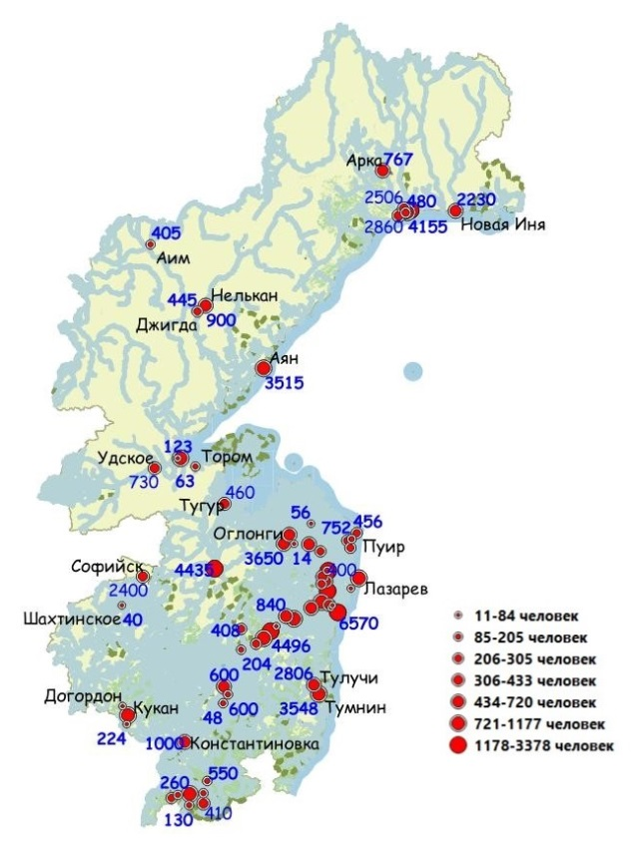

1. Map of Khabarovsk Region

C:\Users\rosa-\Desktop\ВАЖНО\Новая папка (3)\Рисунок 2.tif

1. Dependence of installed power on population, where IP is the installed capacity, P is the population (thousand people), IPapp is the approximation of installed capacity

The required specific (per capita) amount of energy resources can be estimated on the basis of Table 2 and the approximation of the diagram of installed capacity dependence on population (Fig. 2). The assessment shows that the power average of 2.2 kW is required per an inhabitant. The required daily amount of electricity (RE) is determined by the monthly limit set by the Russian government which is 200 kWh per an inhabitant, that as per one day is Enorm = 200/30 = 6.67 kWh/people per day. The incoming energy flows for remote settlements can be estimated from the solar energy distribution maps (Fig. 3) and wind energy distribution maps (Fig. 4) [15].

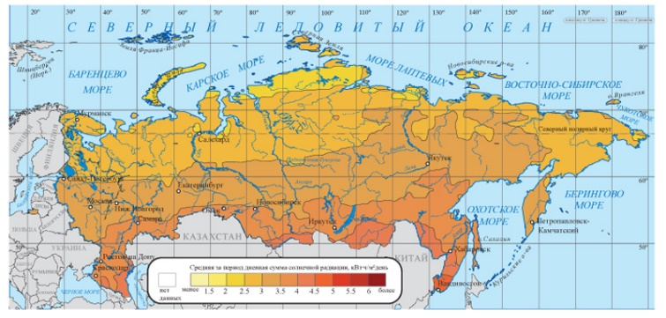

1. Average Daily Total Solar Radiation to the Inclined Surface (inclination angle is equal to latitude) for a Year (on Top) [15]

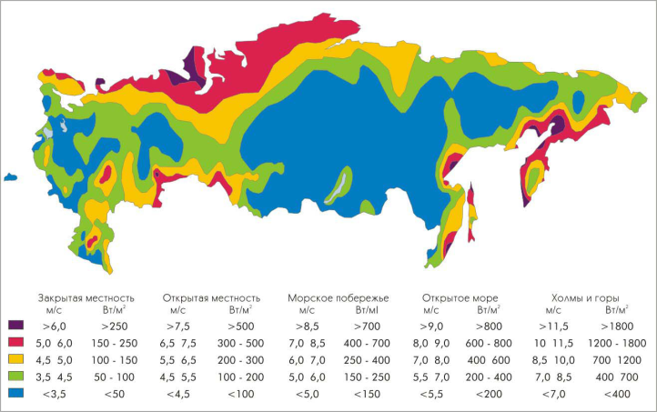

1. Wind Energy Flows in Russia [15]

The results of this assessment are the area covered by solar generators (Ssun_gen) for solar energy flows, the number of wind generators (Nwind_gen) for wind energy flows or both in some proportion.

# Optimization of HPS in remote settlements

The basic HPS is supposed to consist of solar and wind generators and energy accumulators based on electric batteries. It is proposed to use the following algorithm for optimization of HPS of remote settlements.

* Generate a model of the average daily energy balance of a particular settlement.
* Assess the amount of specific equipment required to convert energy flows from renewable sources into electricity.
* Generate a model of annual dynamics of the monthly average daily energy balance of a particular settlement.
* Generate a model of annual dynamics of the average hourly energy balance of a particular settlement.
* Evaluate the required accumulators’ capacity to ensure the average hourly energy balance of a particular settlement.
* Optimize the quantity of equipment for conversion and accumulation of energy flows according to the criterion of minimization of financial costs.

Let us consider the algorithm in more detail on an example of Chilba settlement of Khabarovsk Region located on 51º38ʹ03ʺ of Northern latitude and 140º34ʹ53ʺ of Eastern longitude [16].

* 1. *Generate a model of the average daily energy balance of a particular settlement*

For Chilba it is the most reasonable to generate energy from the Sun and wind. Average daily solar energy flow, in accordance with [15], is equal to SunAD = 3.5 kWh/day∙m2 (see Fig. 3). Specific wind flow is determined by power [15] Wwind = 0.7 kW/m2 (see Fig.4). Maximum average daily consumption is calculated based on the average daily limit per inhabitant set in the Russian Federation [17] and the population of Chilba:

*LoadAD = Enorm ∙ P = 6.67∙34 = 227 kWh/day.* (1)

The expression for average daily balance is as follows:

*LoadAD = Ksun ∙ SunAD ∙ Ssun_gen ∙ Ksun_gen + (1 – Ksun) ∙   
 ∙ SteemWind_EN ∙ Kwind_gen,* (2)

where Ksun_wind is the proportion of solar energy in the approach energy flow;

Ssun_gen is the area of solar generators;

Ksun_gen is the efficiency coefficient of solar generators;

SteemWind_EN = Wwind ∙ Swind_gen ∙ 24 is average daily wind energy;

Swind_gen is the total area of wind generators relative to the wind flow;

Kwind_gen is the efficiency coefficient of wind generators.

* 1. *Assess the amount of specific equipment required to convert energy flows from renewable sources into electricity*

Let us estimate the area of solar generators and the number of wind generators required for average daily consumption. For clarity, we consider the use of BT TRINA SOLAR TSM-DD05A.08 solar generators [18] with the following characteristics: Nominal rating power - 0.3 kW, dimensions - 1.650x0.992 m, efficiency coefficient Ksun_gen = 0.25, cost - $238. And BEKAR BKE.VAWT.10000 wind generators [19] with the following characteristics: Max. power - 10 kW, rotor diameter - 6 m, Swind_gen = 30 m2, max. output power - 12 kW, efficiency coefficient Kwind_gen = 0.35, cost - $3730. Calculate the area of solar generators, considering that wind generators are not used:

*Ssun_gen = LoadAD /(SunAD∙Ksun_gen).* (3)

Calculate the number of wind generators. It shall be noted that although the number of wind generators can only be an integer number, the hypotheses of this value fractionality is introduced for generality:

*Nwind_gen = LoadAD /(SteemWind_EN∙Kwind_gen).* (4)

Calculation results for Chilba and two other settlements are shown in Table 3.

Calculations show that the use of renewable energy sources is sufficient to cover energy needs. Considering that the flow of energy from renewable sources is intermittent, accumulators are required to ensure uninterrupted power supply. To determine accumulators’ parameters, it is necessary to analyze the annual dynamics of monthly and hourly average energy balances.

* 1. *Generate a model of annual dynamics of the monthly average daily energy balance of a particular settlement*

Information from the site of the weather diary for the settlement of Chilba [20] allows getting the dynamics of monthly average daily flows of solar and wind energy. Materials allow making the conclusion on the nature of the dynamics of monthly average daily consumption. Graphically, the dynamics of average daily energy flows of corresponding generators and average monthly consumption is shown in Fig. 5.

Monthly asynchronization of incoming and outgoing power flows confirms the need to use accumulators. Even the combination of solar and wind energy flows in a certain proportion does not make it possible to abandon the accumulators. Subtler effects can only be analyzed at the next hourly average level.

1. Required Parameters for Generators Using Renewable Energy Sources

|  |  |  |  |  |
| --- | --- | --- | --- | --- |
| **Settlement** | **Population, people** | **Required Energy, kWh/d** | **Solar Generator Area, m2** | **Number of Wind Turbines, piece** |
| Chilba | 34 | 227 | 259 | 2 (1.29) |
| Noisy | 280 | 1868 | 2133 | 11 (10.59) |
| Sofiysk | 337 | 2248 | 2567 | 13 (12.74) |

C:\Users\rosa-\Desktop\ВАЖНО\Новая папка (3)\Рисунок 5.tif

1. Diagrams illustrating the dynamics of the monthly average daily energy balance: flow at the outlet of solar generators is a red line; flow at the outlet of wind generators is a blue line; total flow at the outlet of solar and wind generators is a green line; consumption flow is a pink line
   1. *Generate a model of annual dynamics of the average hourly energy balance of a particular settlement.*

The model of annual dynamics of the average hourly energy balance contains three components: model of dynamics of average hourly energy flow from solar generators; model of dynamics of average hourly energy flow from wind generators; model of dynamics of average hourly consumption flow. Let us consider each of these three models development. To create a model of the flow from solar generators, information about the latitude of the settlement is used, as well as a weather diary. According to the sinusoidal law, the intensity of light flux varies during the day (fragments of sinusoids from sunrise to sunset) and during the year (the average value and amplitude of the envelope depends on the latitude of the place), as well as the level of cloudiness, which can be determined from the weather diary for Chilba. The excerpt of light intensity for six days is shown in Fig. 6 by red line.

To create a model of the flow from wind generators information about the dynamics of wind energy flows during a day is used as well as the weather diary on the daily wind speed for Chilba during a year [20]. Combining this information and normalizing it to the average daily flow from the wind generators outlet, we obtain the average hourly dynamics of the wind flow. An excerpt of the wind flow intensity for seven days is shown in Fig. 6.

C:\Users\rosa-\Desktop\ВАЖНО\Новая папка (3)\Рисунок 6.tif

1. Diagrams illustrating the dynamics of the hourly average energy balance (excerpt): flow at the outlet of solar generators is a red line; flow at the outlet of wind generators is a blue line; total flow at the outlet of solar and wind generators is a green line; consumption flow is a pink line; green bars are energy accumulation, purple bars are energy consumption

C:\Users\rosa-\Desktop\ВАЖНО\Новая папка (3)\Рисунок 7.tif

1. Diagrams showing the dynamics of the current accumulator state: a - at zero contingency factor; b - at contingency factor of 3.6%

To create a model of average hourly consumption, information on the dynamics of consumption during a day is used being aggregated with monthly consumption using a random multiplier. An excerpt of average hourly consumption for seven days is shown in Fig. 6 by green line. Analyzing the presented diagram, one can see the periods when consumption exceeds the total solar-wind energy flows (Fig. 6, purple bars). For these periods accumulators are needed.

* 1. *Evaluate the required storage capacity to ensure the average hourly energy balance of a particular settlement*

Let us define the periods when energy can be accumulated and the total incoming flow is greater than consumption (Fig. 6, purple bars) and when the accumulated energy shall be consumed and the total incoming flow is less than consumption (Fig. 6 green bars). Since parameters of solar and wind generators were chosen based on the balance of generated and consumed energy, the total accumulated energy shall be sufficient to cover consumption shortage. But the hourly energy balance is of interest as it may not be achieved.

The structure of the current accumulator state (Fig. 7a) allows one to see time intervals when there is not enough energy in the accumulator to compensate for the lack of solar and wind energy.

As it can be seen, in winter and spring months (December, 12 - May, 05), accumulators do not receive enough energy. To eliminate this problem, it is required to increase the flow of incoming solar and wind energy, increasing the area of solar generators and the number of wind generators. It should be noted that the value of the minimum allowable contingency factor (Kup) of the incoming flow over the nominal value depends on the ratio of solar and wind energy, and this dependence has a minimum (Fig. 8) at 0.72Sun:0.28Wind.

C:\Users\rosa-\Desktop\ВАЖНО\Новая папка (3)\Рисунок 8.tif

1. Dependence diagram of the minimum allowable contingency factor on the ratio of solar and wind energy in the total flow of input energy

Simulation allows determining the diagram of the accumulator current state at the best ratio of solar and wind energy and the optimal contingency factor (Fig. 7b).

The diagram shows that the battery capacity should be  
Capbattmax = 3600 kWh. Let us consider the option of using an electric batteries pack as an accumulator. The number of batteries required is determined by the expression:

*Nbatt = Capbattmax/ Capbatt,* (5)

where Capbatt is the capacity of one battery.

Let us take KORD KRCF 12-170 Carbon batteries [21] with the following characteristics: rated voltage Vbat=12 V, capacity Qbat = 174 A∙h, cost - $776. Accordingly, the energy capacity of one battery is equal to

*Capbatt = Qbatt∙Vbatt = 174∙12 = 2.088 kWh.* (6)

In such pack there should be 1724 batteries that costs 1724∙ 776 = $ 1,337,824 only for purchase. Obviously, this is unacceptably high costs. Thus, there's a contradiction: The cost of HPS is unacceptably increased when the continuity of HPS operation is improved. The principle of Partial or Excessive Action can be used to eliminate this contradiction: use fewer batteries, and in case of excess incoming energy, switch the part of solar and/or wind generators to idle mode (Fig.9a). Thus, another parameter appears - the limit number of batteries and, accordingly, their total capacity. Naturally, the lower is the total batteries capacity (and the lower is their cost), the greater is the need to increase the contingency factor of input energy flows (and the higher is the cost of solar and wind generators). This is an optimization task, which is considered at the next stage.

* 1. *Optimize the equipment quantity to convert and accumulate energy flows as per the minimum cost criterion*

The target function for minimizing cost expenses is as follows:

*Costtotal = Costsun + Costwind + Costbatt → min,* (7)

where Costtotal is the total cost;

Costsun = CostSsun∙ Ssun_gen(Kup) is the cost of solar generators;

CostSsun is a unitary cost (per m2) of solar generators;

Costwind = CostUwind∙ Nwind_gen(Kup) is the cost of wind generators;

CostUwind is a unitary cost (per unit) of wind generators;

Costbatt = CostUbatt∙ Nminbatt(Kup) is the cost of batteries;

CostUbatt is a unitary cost (per unit) of a battery;

Nminbatt(Kup) is the minimum number of batteries at which the minimum current battery charge is within the allowable limits.

It should be noted that some elements of the target function depend on the contingency factor. Indeed, as the cost of batteries pack is considerably exceeds the cost of solar and wind

C:\Users\rosa-\Desktop\ВАЖНО\Новая папка (3)\Рисунок 9.tif

1. Diagrams illustrating the accumulators current state without restriction (red curve) and with restrictions (blue and light blue curves) (a); the dependence of the target function and its components on contingency factor (b)

generators, it is reasonable to reduce the total batteries capacity, but in this case the contingency factor shall be imminently increased. Unfortunately, it is impossible to obtain the analytical dependence of Nminbatt(Kup) on Kup. By simulation (Fig.9b) the dependence of Costtotal on Kup was obtained and the minimum of 139 thousand dollars was determined at Kup = 2.3.

The optimization allows reducing costs by more than 10 times from 1496 to 139 thousand dollars.

# Conclusion

As the result of the research, models of HPS energy balances were developed, both local (average daily, monthly) and global (annual average hourly). The models allow tracing the dynamics of HPS energy balance for a particular settlement. Cost analysis has revealed the determining role of the battery pack cost in the total cost of HPS. The minimum-cost optimization has revealed the optimal ratio of the amount of energy conversion and storage equipment. It is advisable to focus further researches on finding more efficient accumulators to further reduce of HPS equipment cost.

##### References

1. Li Wei, Zhu Xin-jian,  and Cao Guang-yi, “Modeling and control of a small solar fuel cell hybrid energy system,” in Journal of Zhejiang University SCIENCE A, 2007, pp. 734-740.
2. Prashant Baredar, V. K. Sethi, and Mukesh Pandey, “Correlation analysis of small wind–solar–biomass hybrid energy system installed at RGTU Bhopal, MP (India),” in J. Clean Techn. Environ. Policy, 2010, pp. 265-271.
3. Binayak Bhandari, Kyung-Tae Lee, Gil-Yong Lee, Young-Man Cho, and Sung-Hoon Ahn, “Optimization of hybrid renewable energy power systems: A review,” in International Journal of Precision Engineering And Manufacturing-Green Technology Vol. 2, No. 1,, 2015, pp. 99-112.
4. Maurizio Faccio, Mauro Gamberi, Marco Bortolini, and Mojtaba Nedaei, “State-of-art review of the optimization methods to design the configuration of hybrid renewable energy systems (HRESs),” in J. Frontiers in Energy, 2018, pp. 1-32.
5. Yu Fu, Jianhua Yang, and Tingting Zuo, “Optimal Sizing Design for Hybrid Renewable Energy Systems in Rural Areas,” in Book Computer and Computing Technologies in Agriculture, 2010, pp. 131-138.
6. Aayush Sharma, and K. Jamuna, “Coordination of Energy Storage Devices in Hybrid Power Systems,” in Book Emerging Trends in Electrical, Communications and Information Technologies, 2018, pp. 327-336.
7. Bahman Zohuri, “Hybrid Renewable Energy Systems,” in Book Hybrid Energy Systems, 2017, pp. 1-38.
8. Jure Margeta, and Zvonimir Glasnovic, “Hybrid RES-HEP Systems Development,” in J. Water Resour Manage, 2011, pp. 2219-2239.
9. Surabhi Chandra, Prerna Gaur, and Srishti, “Maximum Power Point Tracking Approaches for Wind–Solar Hybrid Renewable Energy System-A Review,” in Book Advances in Energy and Power Systems, 2018, pp. 3-12.
10. Amina Gaabour, Abderrezak Metatla, Ridha Kelaiaia, Farid Bourennani, and Adlen Kerboua, “Recent Bibliography on the Optimization of Multi-source Energy Systems,” in J. Archives of Computational Methods in Engineering, 2018, pp. 1-22.
11. Lin Feng, Jingning Zhang, Guojie Li, and Bangling Zhang, “Cost reduction of a hybrid energy storage system considering correlation between wind and PV power,” in J. Protection and Control of Modern Power Systems., 2016, pp. 1-9.
12. Zaeem Moosavi Mohamadi, and Hassan Zohoor “Introducing a dimensionless number as tank selector in hybrid solar thermal energy storage systems,” Journal of Mechanical Science and Technology, 2011, pp. 871-876.
13. Zaeem Moosavi Mohamadi, and Hassan Zohoor “Introducing a dimensionless number as tank selector in hybrid solar thermal energy storage systems,” Journal of Mechanical Science and Technology, 2011, pp. 871-876. [036]
14. Analysis of the Current State of Isolated Power Systems with High Costs for Energy [Digital Resorce]. URL: <http://www.cenef.ru/file/Discussion_paper1.pdf>, last accessed 2016/06/20.
15. Maps of the Joint Institute for High Temperatures of the Russian Academy of Sciences and the Geography Department of M.V. Lomonosov Moscow State University (O.S. Popel, S.E. Frid, Y.G. Kolomiets, S.V. Kiseleva, E.N. Terekhova Atlas of Solar Energy Resources on the territory of Russia. - – М.: OIVET RAS, 2010. 84 p.)
16. Wikipedia. Chilba. <https://ru.wikipedia.org/wiki/Чильба#/maplink/1>, last accessed 2016/06/20.
17. Government of the Russian Federation Decree No. 614 dd July 22, 2013. <http://docs.cntd.ru/document/499035391>, last accessed 2016/06/20.
18. SiNT. Solar Panels. TSM-300DD05A.08  
    <https://sint.tech/solar-panels/tsm-300dd05a-08>, last accessed 2016/06.20.
19. SUN PROJECT. BEKAR wind generator with vertical rotation axis of the 4th generation. <http://solar-project.ru/BKE.VAWT.10000>last accessed 2016/06/15.
20. Gismeteo.ru - weather forecast. <https://www.gismeteo.ru>, last accessed 2016/06/10.
21. ALTEKO. Battery KORD KRCF 12-170 (Carbob). <http://www.altecology.ru>, last accessed 2016/06/15